Department of Computer Science and Engineering (Data Science)
CSDS-A | Batch A13 (CSE - Data Science, Section A)
AI-Enabled Digital Examination Seating Management System
(SeatWise)
S.No. | Student name | Roll / hall ticket no.
1 | A.SANJAY | 23K91A6702
2 | CH.NAVEEN | 23K91A6743
3 | D.KOTESH | 24K95A6705
4 | A.AKSHITH | [Roll number to be confirmed]
Under the guidance of: [GUIDE NAME], [DESIGNATION]
DESIGN AND IMPLEMENTATION
This document describes the design of SeatWise and how it was implemented: the architecture, the modules, the database schema, the API, key code walkthroughs, and the reasoning behind the main implementation decisions.

1 Overall System Architecture
SeatWise is a single-machine web product: a FastAPI back end with an SQLite database and a React front end served by Vite. Everything runs offline once installed.
The architecture has four layers. Users work in a browser on a PC, tablet or phone: the examination controller on the administrator console, the invigilator on a tablet, and the public on the home and lookup pages. The React front end (port 5113) provides the pages, the seat map and the charts, and it reaches the back end through a data layer that sends the JWT in the Authorization header. The Vite development server forwards /api to the back end, so tablets and phones only need one address.
The FastAPI back end (port 8113) exposes a REST API with JWT authentication, role checks and a rate limit on public endpoints. Behind it sit eight services: the importer, the seating engine, an independent validator, the swap checker, the exports, the attendance service, analytics and the audit service. The back end owns every rule: the front end never decides whether a seat move is legal; it asks the API, so the seat map, the exports and the benchmark all apply identical checks. SQLite stores 16 tables, and a small profile file records the tuned solver budget and the latest benchmark results.
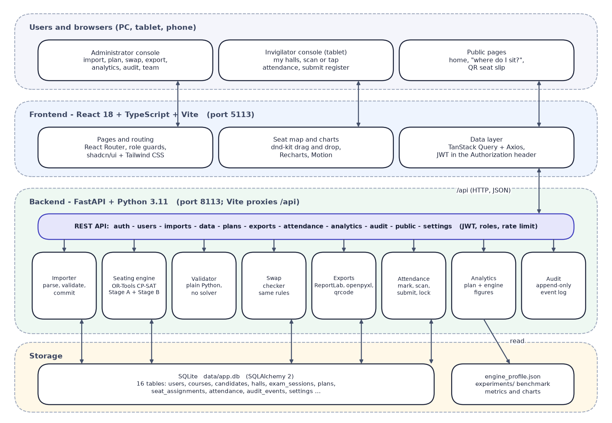
Fig. 1: System architecture of SeatWise
Table 1: Layers of the architecture
Layer | Technology | Responsibility
Browser | Chrome or Edge on PC, tablet or phone | Administrator console, invigilator register, public lookup
Front end | React 18, TypeScript, Vite, Tailwind CSS, shadcn/ui, TanStack Query, dnd-kit, Recharts | Pages, seat map, charts, role guards, API calls
API | FastAPI, Pydantic v2, JWT (PyJWT), bcrypt | REST endpoints, authentication, authorisation, errors
Services | Importer, engine, validator, swap checker, exports, attendance, analytics, audit | All business rules and outputs
Solver | Google OR-Tools CP-SAT 9.15 | Stage A and Stage B optimisation
Storage | SQLite through SQLAlchemy 2 | 16 tables; created automatically on first start

2 Module Design
The code is organised so that rules live in one place and every layer can be tested separately. Package sizes are the actual line counts of the delivered code.
Table 2: Modules and their size
Package | Files | Lines | Responsibility
backend/app/api | 13 | 899 | One router per area: auth, users, imports, data, plans, exports, attendance, analytics, audit, public, settings, health
backend/app/core | 7 | 292 | Settings from .env, database session, security, dependencies, error types, logging
backend/app/models | 7 | 308 | SQLAlchemy entities for the 16 tables
backend/app/schemas | 5 | 362 | Pydantic request and response models
backend/app/services/engine | 10 | 1,023 | Seat graph, pre-checks, roll numbers, Stage A, Stage B, engine loop, validator, baselines
backend/app/services/importer | 6 | 1,031 | Parse CSV or XLSX, validate each kind, cross-checks, commit, templates
backend/app/services/exports | 7 | 747 | Seating charts, invigilator sheets, QR slips (PDF); hall lists and attendance (Excel)
backend/app/services (other) | 12 | 1,006 | Plans, swap, attendance, analytics, audit, hall map, sessions, rate limit, seed data
ml (benchmark) | 6 | 726 | Scenario generator, baselines, benchmark runner, predictability and plots
backend/tests | 11 | 813 | 58 pytest tests
frontend/src/pages | 19 | 4,872 | Public, authentication and 13 application pages
frontend/src/components, lib | 52 | 3,787 | Layout, seat map, charts, UI kit, API client, auth, theme
scripts | 24 | 3,662 | Setup checks, sample data, demo scenario, and the documentation tools of this report

2.1 Engine modules
- graph.py builds each hall's seat graph and its colour classes (the key geometric idea).
- prechecks.py produces plain-language reasons for impossible requests.
- stage_a.py allocates candidate groups to halls and colour classes with CP-SAT in two passes.
- stage_b.py lays out the seats of one hall with CP-SAT.
- engine.py runs the loop: pre-check, Stage A, split, Stage B in parallel, retry.
- validator.py is the independent checker and scorecard; rolls.py parses roll numbers; baselines.py creates the manual baselines.

3 Entity-Relationship Diagram and Database Schema
The database has 16 tables. Reference data comprises departments, courses, candidates, registrations (the many-to-many link between candidates and courses), halls and the timetable (exam sessions and session papers). A plan belongs to an exam session and owns its seat assignments, invigilator assignments, attendance marks and hall submissions. Users, audit events, import batches and settings support the application. Every foreign key is marked in its table; only the principal relationships are drawn so that the diagram stays readable.

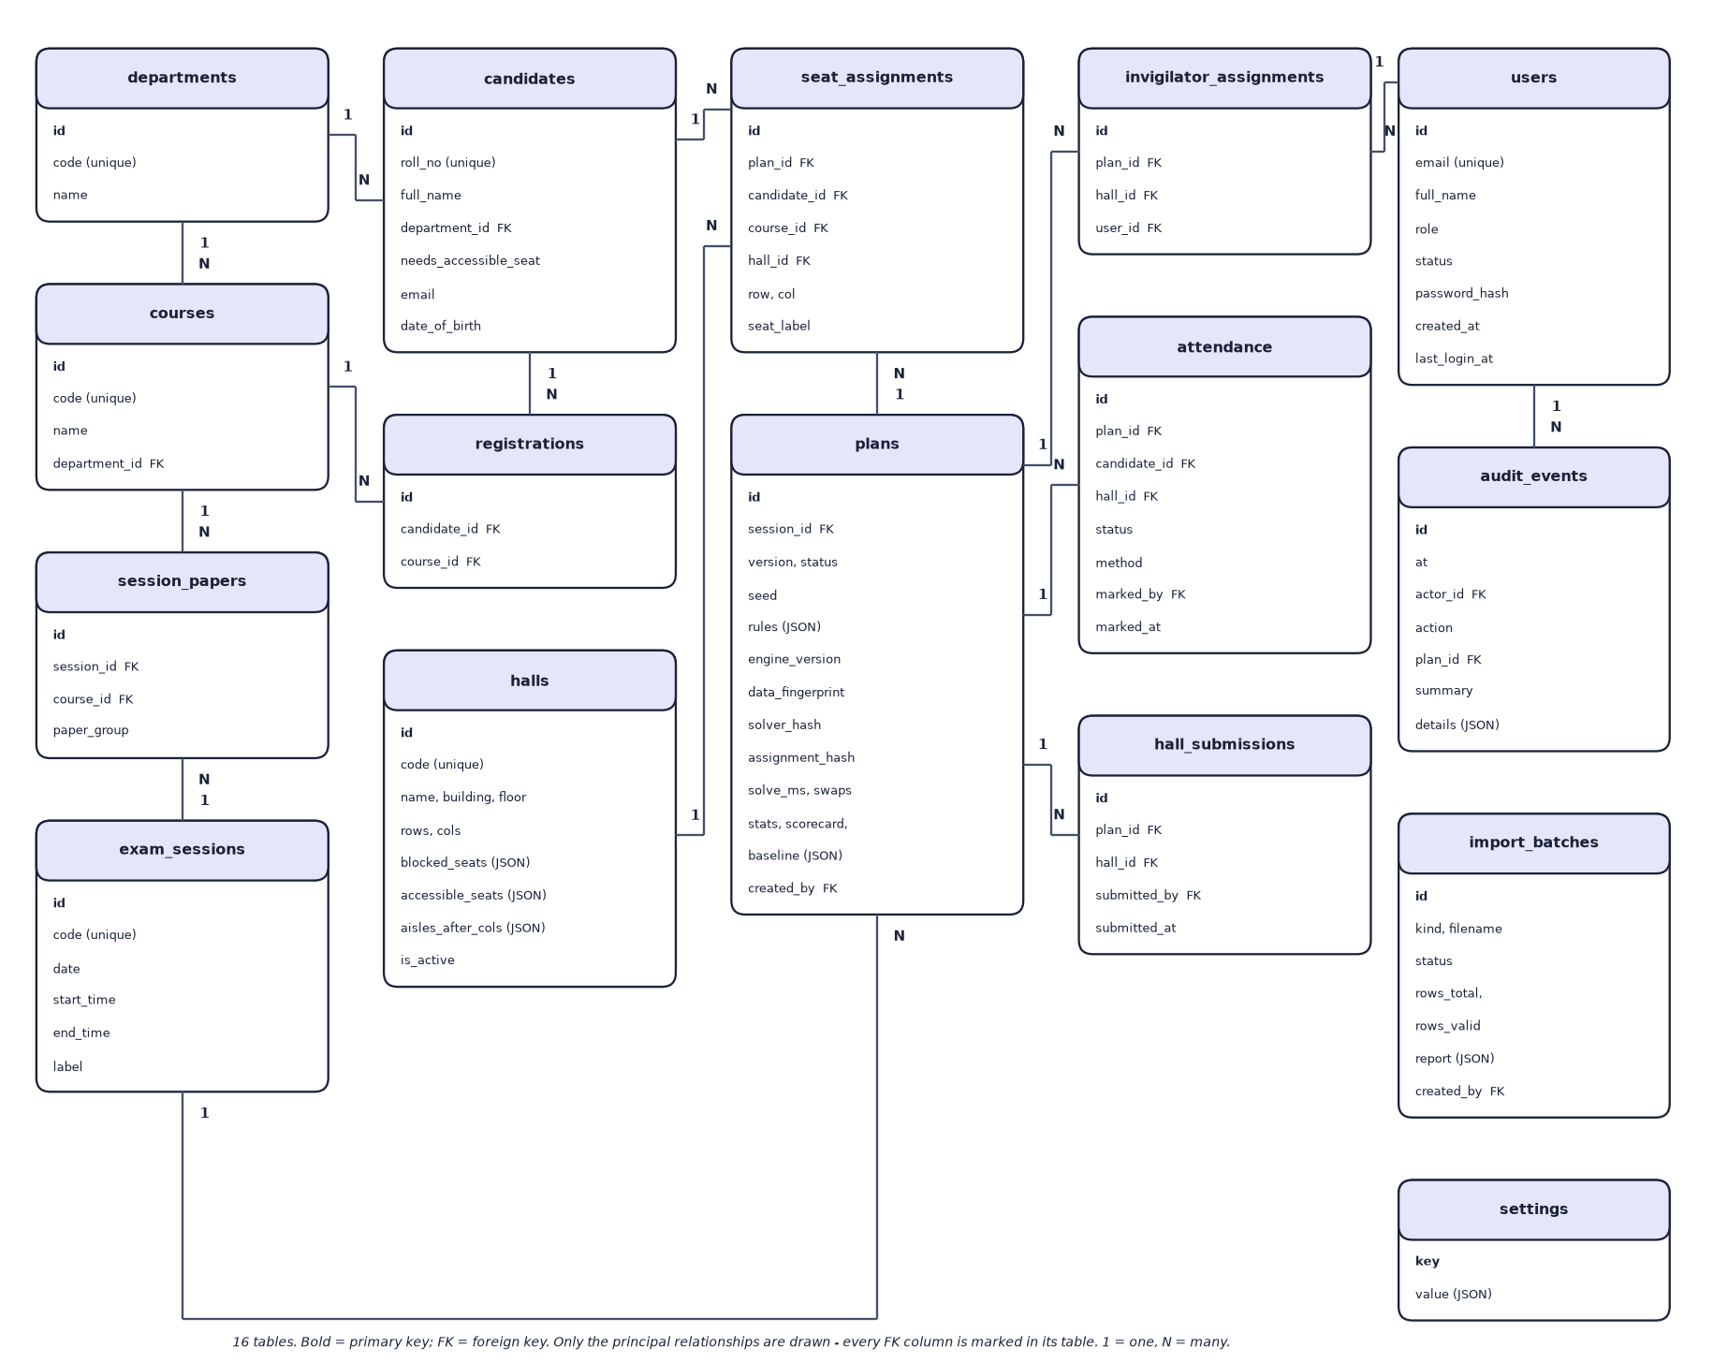
Fig. 2: Entity-relationship diagram of the SeatWise database (16 tables)

The tables are created by SQLAlchemy when the application starts, so no separate migration step is needed for a first install. Unique constraints protect the main invariants: one registration per candidate and course, one seat per candidate in a plan, one candidate per seat of a hall in a plan, one attendance mark per candidate and plan, and one version number per sitting.
Table 3: Database tables
Table | Purpose | Key columns
users | Administrators and invigilators | email (unique), role, status (active, pending, disabled), password_hash
departments, courses | Course catalogue | code (unique), name, department_id
candidates | Candidates | roll_no (unique), department_id, needs_accessible_seat, email, date_of_birth
registrations | Courses a candidate sits | candidate_id, course_id (unique pair)
halls | Hall layouts | rows, cols, blocked_seats, accessible_seats, aisles_after_cols (JSON), is_active
exam_sessions | Sittings | code, date, start_time, end_time, label
session_papers | Courses examined in a sitting | session_id, course_id, paper_group (shared question paper)
plans | A version of a sitting's seating | status, seed, rules, engine_version, data_fingerprint, solver_hash, assignment_hash, solve_ms, scorecard, baseline
seat_assignments | Candidate to seat | plan_id, candidate_id, course_id, hall_id, row, col, seat_label
invigilator_assignments | Who supervises a hall in a plan | plan_id, hall_id, user_id
attendance | Marks per candidate | plan_id, candidate_id, hall_id, status, method, marked_by, marked_at
hall_submissions | Register lock | plan_id, hall_id, submitted_by, submitted_at
import_batches | Every upload and its report | kind, filename, status, rows_total, rows_valid, report, payload
audit_events | Append-only log | at, actor_id, action, plan_id, summary, details (JSON)
settings | Default rules | key, value (JSON)

4 Application Architecture and Implementation
Request flow. The browser calls /api/... on the Vite server, which forwards the request to Uvicorn. A FastAPI router validates the request with a Pydantic model, a dependency decodes the JWT and checks the role, and the router calls a service function with a SQLAlchemy session. Services raise typed errors (AppError, NotFound), which a handler converts to a JSON body {detail, details} with the matching HTTP status. Plan generation is a synchronous request that typically takes two to three seconds; the interface shows progress stages while it waits.
Front end. Pages are loaded on demand. TanStack Query caches server state and refreshes attendance every few seconds so that several devices stay in step. The seat map uses dnd-kit for drag and drop and also supports tap-then-tap and keyboard operation; while a candidate is picked up it calls the swap-check endpoint and colours every seat from the answer. Charts are drawn with Recharts and each has a table view.
Outputs. ReportLab draws one landscape page per hall for the seating chart, with the colour legend, the invigilator and a stamp of plan version, seed and seating fingerprint. Invigilator sheets list papers and a seat-by-seat table with present and signature columns. Seat slips (six per page) carry a QR code whose URL opens the candidate's lookup page. openpyxl writes the hall lists (a summary sheet, one sheet per hall, and a door list in roll order) and the attendance report.
Attendance. The attendance service marks candidates by tap, by scanned slip or by typed roll number. A scan of a candidate who sits in another hall reports where the candidate sits. A register can be submitted only when every candidate is marked, and a submitted register is locked until an administrator reopens it.

5 API Design
The API is a JSON REST interface under /api, documented interactively by FastAPI at /docs. It has 57 operations. Access is public (no token), signed-in (any active account) or admin; invigilators may use hall-level endpoints only for halls they are assigned to in published plans.
Table 4: API areas
Area | Representative endpoints | Access
Health and authentication | GET /health; POST /auth/login; POST /auth/register; GET /auth/me | Public; signed-in
Team | GET, POST /users; PATCH /users/{id} | Admin
Settings | GET, PUT /settings/rules; POST /settings/reset-workspace | Signed-in; admin
Import | GET /imports/templates/{kind}; POST /imports/{kind}/validate; POST /imports/{id}/commit | Admin
Data | GET /data/summary, /candidates, /courses, /halls, /sessions | Signed-in; admin
Plans | POST /sessions/{id}/plans; GET /plans/{id}; POST /plans/{id}/publish; POST /plans/{id}/verify; DELETE /plans/{id} | Admin
Seat maps | GET /plans/{id}/halls/{hall}; GET .../swap-check?seat=C4; POST /plans/{id}/swap | Admin; assigned invigilator (read)
Exports | GET /plans/{id}/exports/seating-charts.pdf, invigilator-sheets.pdf, hall-lists.xlsx, qr-slips.pdf, attendance.xlsx | Admin; invigilator for own hall
Attendance | GET /attendance/assignments; PUT .../attendance/{candidate}; POST .../scan, .../mark-remaining-absent, .../submit, .../reopen | Signed-in; admin to reopen
Public | GET /public/lookup/{id}; GET /public/slip/{id}/{plan}.pdf; GET /public/engine-summary | Public, rate-limited
Analytics and audit | GET /analytics/overview, /analytics/plans/{id}, /analytics/engine; GET /audit | Admin

Errors use consistent codes: 400 bad input, 401 not signed in or expired, 403 not allowed for the role, 404 not found, 409 conflict with the current state (a blocked move, a locked register), 422 validation failed or no plan is possible, and 429 rate limited. Examples of real responses are in the API reference in the project documentation.

6 Key Code Walkthroughs
The excerpts below are copied from the delivered source; Appendix A lists further code.

6.1 Seat graph and colour classes
graph.py defines neighbours, the colouring and the per-paper ceiling. Aisles and blocked seats only remove edges.
Listing: neighbours of a seat (graph.py)
def neighbours_of(hall: EngineHall, seat: Seat, adjacency: int) -> list[Seat]:
r, c = seat
out = []
for dr, dc in _OFFSETS[adjacency]:
nr, nc = r + dr, c + dc
if 0 <= nr < hall.rows and 0 <= nc < hall.cols and (nr, nc) not in hall.blocked \
and not _crosses_aisle(c, nc, hall.aisles_after):
out.append((nr, nc))
return out

Listing: colour class of a seat (graph.py)
def seat_class(seat: Seat, adjacency: int) -> int:
"""Colour of a seat in a proper colouring of the seat graph.

8 neighbours: four classes by (row parity, column parity) - two seats of one
class differ by at least two rows or two columns, so they are never
neighbours. 4 neighbours: the two chessboard colours. Aisles and blocked
seats only remove edges, so the colouring stays valid.
"""
r, c = seat
return (r % 2) * 2 + (c % 2) if adjacency == 8 else (r + c) % 2

6.2 Stage B constraints
Stage B declares one boolean variable per candidate and allowed seat. The roll-gap rule is expressed as at-most-one clauses, and the objective combines the department penalty with the seeded random term.
Listing: Stage B model, assignment and roll-gap clauses (stage_b.py)
model = cp_model.CpModel()
x: dict[tuple[int, int], cp_model.IntVar] = {}
by_seat: dict[int, list] = defaultdict(list)
for ci, options in enumerate(allowed):
row = []
for s in options:
var = model.NewBoolVar("")
x[ci, seat_index[s]] = var
by_seat[seat_index[s]].append(var)
row.append(var)
model.AddExactlyOne(row)
for vars_on_seat in by_seat.values():
if len(vars_on_seat) > 1:
model.AddAtMostOne(vars_on_seat)

# Roll-number spacing. Pairs in the same class can never be neighbours, so only
# pairs in different classes need a constraint.
for i, j in close_pairs([c.roll_no for c in cands], rules.roll_gap):
if paper_class[cands[i].paper] == paper_class[cands[j].paper]:
continue
for s in allowed[i]:
around = [x[j, seat_index[t]] for t in neighbours[s] if (j, seat_index[t]) in x]
if around:
model.AddAtMostOne([x[i, seat_index[s]], *around])

6.3 The engine loop
solve runs the pre-check, Stage A, the seeded split and Stage B per hall, and handles retries as described in the flowchart.
Listing: retry loop of the engine (engine.py)
for attempt in range(max_retries + 1):
allocation = None
for stretch in (1, 4):
allocation = allocate(candidates, halls, rules, capacity=capacity,
seed=derive_seed(seed, f"stage-a-{attempt}"), budget=STAGE_A_BUDGET * stretch)
if allocation is not None:
break
if allocation is None:
return done(False, [], [
"No way to share the candidates between the selected halls satisfies every rule. "
"Select more halls, or relax the rules (4-neighbour adjacency or a smaller roll-number gap)."])

rng = np.random.default_rng(derive_seed(seed, f"split-{attempt}"))
per_hall = _split_by_hall(candidates, allocation.counts, halls, rng)
stage_b_started = time.perf_counter()

def run(keys: list[str], hall_budget: float) -> dict[str, HallSolve]:
with ThreadPoolExecutor(max_workers=min(threads, max(1, len(keys)))) as pool:
futures = {
key: pool.submit(solve_hall, hall_by_key[key], per_hall[key], allocation.paper_class[key], rules,
seed=derive_seed(seed, f"hall-{key}-{attempt}"), budget=hall_budget,
workers=workers_per_hall)
for key in keys
}
return {key: f.result() for key, f in futures.items()}

results = run(sorted(per_hall), budget)
slow = sorted(k for k, r in results.items() if r.status == "no_solution_in_budget")
if slow:
results.update(run(slow, budget * SLOW_HALL_BUDGET_FACTOR))

6.4 Plan generation and storage
generate in plans.py refuses to store a plan that the validator rejects, and records the seed, the rules and the fingerprints.
Listing: storing a plan (plans.py)
card = validate(candidates, halls, sequential(candidates, halls, rules), rules)
except ValueError:
return {}
return {"method": "sequential roll order", "same_paper_pairs": card.same_paper_pairs,
"roll_gap_violations": card.roll_gap_violations, "same_department_pairs": card.same_department_pairs,
"accessible_violations": card.accessible_violations, "neighbour_pairs": card.neighbour_pairs}
...
plan = Plan(
session_id=session.id, version=version, status=PLAN_DRAFT, seed=seed, rules=rules_in.model_dump(),
hall_ids=hall_ids, engine_version=ENGINE_VERSION,
data_fingerprint=data_fingerprint(candidates, halls, rules, budget),
solver_hash=solver_hash, assignment_hash=solver_hash, solve_ms=result.solve_ms,
stats={**result.stats, "hall_budget": budget}, scorecard=_card_summary(card),
baseline=_baseline(candidates, halls, rules), created_by=user.id,
)

6.5 Live swap check
The swap checker applies the same neighbour graph and roll-gap functions to a hypothetical move and returns reasons.
Listing: rule check of one seat after a move (swap.py)
def check_seat(seat: tuple[int, int], who: Occupant) -> None:
label = seat_label(*seat)
if who.needs_accessible and seat not in accessible:
reasons.append(f"{who.roll_no} needs an accessible seat and {label} is not one.")
for n in neighbours.get(seat, []):
near = after.get(n)
if near is None or near is who:
continue
if near.paper == who.paper:
reasons.append(f"{who.roll_no} would sit next to {near.roll_no} ({seat_label(*n)}) - both write {who.paper}.")
if violates_gap(who.roll_no, near.roll_no, rules.roll_gap):
reasons.append(f"Roll numbers {who.roll_no} and {near.roll_no} ({seat_label(*n)}) are only "
f"{roll_distance(who.roll_no, near.roll_no)} apart (minimum {rules.roll_gap}).")
if rules.department_mix and near.department == who.department and near.paper != who.paper:
notes.append(f"{who.roll_no} and {near.roll_no} are both from {who.department}.")

7 Implementation Decisions and their Reasoning
Table 5: Implementation decisions
Decision | Alternatives considered | Reasoning
Constraint programming (CP-SAT) for the engine | Sorting, zipper interleave, greedy colouring, genetic search | Exact on hard rules; can prove infeasibility; rules are added as constraints; seeded objective gives controlled randomness
Two stages (allocation, then layout) | One model over all seats of all halls | Smaller models, parallel halls, and the colour-class construction that makes same-paper neighbours impossible
Colour classes by (row parity, column parity) | Search for a colouring per hall | Explicit, provably proper colouring; no search; works with aisles and blocked seats because they only remove edges
Deterministic time budget, one worker per hall | Wall-clock limits, many workers | A wall-clock limit would make results depend on machine load; determinism makes plans reproducible
Sub-seeds derived by SHA-256 | Python's built-in hash or sequential seeds | Stable across runs and machines (Python hash randomisation would break reproducibility)
Independent validator | Trust the solver | A plan is never stored unless a solver-free check agrees; the same checks serve the swap map and the benchmark
Backend owns the rules | Check moves in the browser | One set of rules for the map, the exports and the benchmark; no rule drift
FastAPI with Pydantic and SQLAlchemy | Flask (the base paper's choice), Django | Typed request models, automatic OpenAPI documentation, simple tests with a test client
SQLite | PostgreSQL or MySQL | No server to install for one office; created on first start; adequate for the measured load. A server database is future work
JWT with bcrypt | Server-side sessions | Stateless API suitable for tablets and phones; short-lived tokens; passwords never stored in clear
React with TanStack Query and dnd-kit | Server-rendered pages (the base paper's Jinja2) | Responsive seat map with drag, tap and keyboard operation and live checks
Vite proxy for /api | Direct calls to the API port | One address for tablets and phones; no CORS configuration for users
Synthetic seeded data | Real student data | No privacy risk; reproducible; exercises every rule (shared papers, clashes, accessibility)
Benchmark with baselines instead of accuracy metrics | Reporting accuracy-style numbers | Nothing is trained; violations and speed are the honest measures

8 Security and Error Handling
Table 6: Security controls
Concern | Control in SeatWise
Passwords | bcrypt hashes through passlib; minimum length enforced on registration; demo password changeable
Sessions | Signed HS256 JWT with 12-hour expiry; secret generated by setup.bat and kept only in .env, which is never committed
Authorisation | Role dependency on every router; invigilators limited to assigned halls of published plans; the last active administrator cannot be demoted or disabled
Account creation | Self-registration creates a pending invigilator account that an administrator must approve
Public data | Public endpoints return published seats only, a shortened name (for example Maya F.), no e-mail or date of birth, and are rate-limited per client (30 a minute by default)
Input validation | Pydantic models on every request; import files validated row by row; upload size limit; path-traversal attempts on served chart files refused
Integrity | Plans that fail the validator are never stored; imports are applied once; published plans cannot be deleted; registers lock after submission
Auditability | Append-only audit events for imports, plans, seeds, moves, publications, downloads and attendance
Errors | Typed application errors become readable JSON messages; unexpected errors are logged and return a generic 500 without internals

Limits of the security work: no penetration test was carried out, HTTPS is not configured by default (a deployment concern), and the demo accounts are for demonstration only.

9 User Interface Design
The interface was designed around the three audiences. Administrators get a sidebar with Prepare (import, data), Seating (sittings and plans, exports, attendance, analytics, audit trail) and Workspace (team, settings). Invigilators see only their halls and the attendance screen. Candidates see a public home page and a lookup page. Principles applied throughout: every list has a loading state, an empty state and a Try again action; every chart has a table view; colours carry a second cue (icons, labels) so that they are not the only signal; the layout works from 360 px to desktop; and a sun or moon button switches between light, dark and system themes.
The seat map is the central screen. The front of the hall is at the top, rows are lettered from the front and seats are numbered from the left. Each seat shows its label, roll number and course, with a coloured top edge for the paper. Picking up a candidate turns every other seat green (the move keeps every rule) or red (with the reason on hover or focus).
Real captures of the seat map and the dashboard are shown in Chapter 8.
Table 7: Screens of the application
Screen | Route | Audience | Purpose
Home | / | Public | Overview, headline benchmark figures, links to lookup and sign-in
Sign in, Request account | /login, /register | Public | Authentication; demo workspace buttons
Dashboard | /app | All staff | Getting-started steps, figures, charts, sittings, busiest halls
Import data | /app/import | Admin | Upload, validation report, preview, commit, templates
Data | /app/data | Admin | Candidates, courses, halls, timetable
Sittings and plans | /app/sessions, /app/sessions/:id | Admin | Generate, versions, scorecard, publish, verify, invigilators
Seat map | /app/plans/:plan/halls/:hall | Admin; invigilator (read-only) | View and edit seats with live checks
Exports | /app/exports | Admin | Charts, lists, sheets, QR slips, attendance report
Attendance | /app/attendance, /app/attendance/:plan/:hall | Staff | Take and submit attendance
Analytics | /app/analytics | Admin | Plan comparison charts; engine performance
Audit trail | /app/audit | Admin | Filterable event log
Team, Settings | /app/team, /app/settings | Admin | Accounts and default rules
Find my seat | /lookup, /lookup/:id | Public | Seat lookup and QR slip

10 Installation and Execution
SeatWise targets Windows 10 and 11 with Python 3.11 and Node.js LTS. The full steps are in Appendix B; in outline:
1. Run setup.bat once (about five minutes on a clean machine; 108 s was measured on a clean copy). It creates the virtual environment, installs the packages, creates .env with a random login secret, installs the web packages, creates the database and runs a checklist.
2. Run run.bat. It starts the API on port 8113 and the web app on port 5113, waits until both answer, and opens http://localhost:5113. It refuses to start if a port is busy.
3. Sign in with a demo account, import the sample workbook, generate and publish a plan.
4. Run stop.bat to stop both servers.
The backend tests run with pytest in the backend folder, the engine benchmark with python -m ml.benchmark (about seven minutes), and the scripted scenario with scripts/demo_scenario.py.

